Universidad del Cauca
Facultad de Ingeniería Electrónica y Telecomunicaciones

Programas de Maestría y Doctorado en Ingeniería Telemática
Seminario de Investigación

Traffic Prediction base don Big Data Tecnologies for Configuring Software – Defined Networks

Relator: Felipe Estrada Solano, estudiante de Doctorado
Co-relator: Oscar Mauricio Gómez.
Protocolante: Luz Marina Sierra M, estudiante de Doctorado

Fecha: 22 de abril de 2016
Hora inicio: 10:00 a. m.
Hora fin: 10:50 a. m.

Lugar: Salón de posgrado, FIET, Universidad del Cauca, Popayán

Asistentes:
Juan Carlos Corrales, Coordinador del seminario
Felipe Estrada Solano, estudiante de Doctorado, Relator
Dr. Oscar Mauricio Caicedo, Co-relator
Ing. Iván Hernández, Profesor Departamento de Telemática
Estudiantes de Maestría y Doctorado en Ingeniería Telemática
Estudiantes de pregrado de la FIET

Orden del día:
- Presentación a cargo del relator
- Intervención del co-relator
- Preguntas
- Conclusiones

Desarrollo

- Presentación a cargo del relator

El Ingeniero Felipe Estrada, presentó su avance en pro de definir el tema de su proyecto de Doctorado, para lo cual había preparado la siguiente agenda:
- Background
- Motivation
- Initial Approach
- Systematic Mapping
- Conclusions
- Ph.D. study plan

The presentation starts:

BACKGROUND,
Three concepts are presented: Software-Defined Networking, traffic engineering, and Big Data.

Software-Defined Networking [Feamster et al., 2013), (Kim and Feamster, 2013),
(Anwer and Feamster, 2010), (Shimonishi and Ishi, 2010)].
- Defines a new architecture for future networks that overcomes the difficult management of conventional networks.
- Separates the Data and the Control planes, allowing a simpler network operation from a logically centralized software program, also known as controller, allowing a simpler network operation.
- The control plane communicates with the Data Plane through an SDN Protocol.

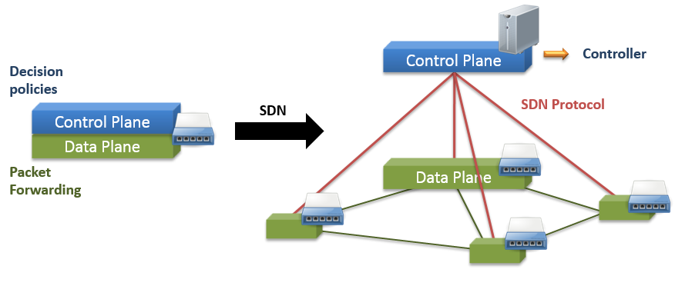
Figure 1. SDN

An example of SDN is presented in Figure 1, it shows a typical SDN Architecture composed of three horizontal planes and three interfaces.
Data Plane deploys the network infrastructure made up of interconnected network devices for packet forwarding.
The control Plane deploys a Network Operative System, or Controller, that compiles the network logic and enforces decision policies on the Data Plane through Southbound interfaces, or SBI. This control Plane also defines East/Westbound Interfaces to deploy distributed Controllers and includes Network Slicers that visualize the underlying Data Plane, allowing multiple Controllers running over the same network infrastructure. Such controller provide generic services and Northbound Interfaces to the Application Plane, facilitating to develop and integrate custom Network Applications.
The application plane contains Network Application that execute high level networking functions.

Recent investigations have considered a Management Plane in the SDN architecture that interacts with environment. For the master’s degree project, the management plane was extended by proposing a high level approach based on the Open System Interconnection network management model, which divides into four submodels: Information, Organizational, Communication, and Functional. Then it was focused on defining the information model by using the Common Information Model Specification to represent the SDN environment from a management perspective and, also, designed a mashup-based and event driven framework that allows Networks Administrators to easily build an execute SDN management tools. The figure 2 presents this architecture described above.

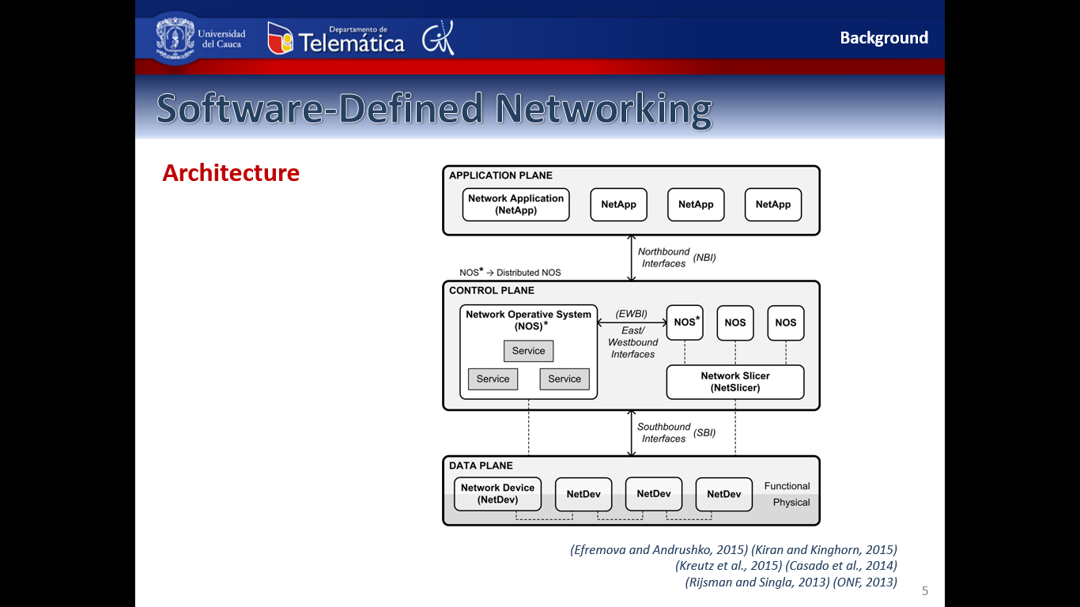
Figure 2. Software-Defined Networking
Source: (Estrada-Solano et al., 2016)(Wickboldt et al., 2015)(ONF, 2014) (Efremova and Andrushko, 2015) (Kiran and Kinghorn, 2015) (Kreutz et al., 2015) (Casado et al., 2014)
(Rijsman and Singla, 2013) (ONF, 2013)

Traffic engineering, defines mechanisms that dynamically analyze, recognize, classify, predict and regulate traffic to improve network management. For example, a specific mechanism may classify various traffic types from distinct applications to provide the most suitable network service for each traffic type in a very short time period. Therefore, traffic engineering represents an interesting opportunity to improve management techniques for every SDN management functional area, which we defined in our previous work as FAULT, CONFIGURATION, ACCOUNTING, PERFORMANCE, SECURITY and PROGRAMMING. This is FCAPS + P Model.

BigData has evolved as solution to tackle the challenges in data management, describing six dimensions, also known as the 6Vs:
Volume, that refers to the vast amount of data.
- Velocity, that is related to the rate at which data are generated and should be analyzed.
- Variety, that makes reference to the different types of data.
- Veracity, refers to the integrity of the data.
- Variability, is related to the different data flow rates.
- Value, reference to obtaining significant results from data.

Big data has been applied in different domains, including networking where experts highlight that is going to have short and long term benefits in the obtain in the future Internet. In short words, Big Data allow to collect and analyze huge amounts of data to obtain significant results for predicting events and improving decision-making.

Source: (Gandomi and Haider, 2015) (Marr, 2014) (Mayer-Schönberger and Cukier, 2013)(Oracle, 2013) (Cloud Computing Consortium, 2012) (Laney, 2001)

MOTIVATION

Four major advantages of the SDN architecture for operating networks.
First, a centralized global view about the network state, such as resource capabilities and dynamic status, and about the deployed applications, such as quality requirements and service agreements.
Second, a dynamic programmability of multiple forwarding devices, for example, for allocating resources to prevent congestion and improve performance.
Third, open interfaces for handling the Data Plane, such as Open Flow, and for developing the Application Plane, like APIs based on protocols and programming languages.
Fourth, a flexible flow management, specially in Open Flow because of its multiple flows tables.
These uniques features lead the SDN architecture to emerge as a promising scenario for efficiently and intelligently implementing management techniques, particularly traffic engineering.

From an SDN deployment, a management component can collect and store data in order to perform specific analysis techniques and take decisions based on the obtained results. These decisions allow applying SDN configurations that optimize the network performance. For example, updating the packet forwarding by using predicted traffic patterns. Therefore, the knowledge of relationships between network status and network configuration may help network to decide the best parameters according to real performance feedback (See Figure 3).

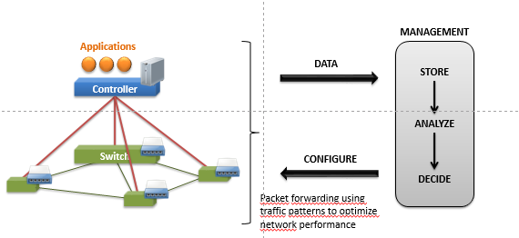
Figure 3. Traffic engineering in SDN.

Nevertheless, there are some SDN deployments, such as datacenters and wide area networks, that generate huge amounts of data. Then, the question is how to apply traffic engineering in a data intensive SDN environment?. One possible solution is to integrate Big Data technologies.

INITIAL APPROACH

The initial approach is to address traffic engineering for configuring SDNs, working along with the network core, with Big Data approaches.

In the Computer Networks groups guided by Ph.D. Oscar Caicedo, we address this approach as following (See Figure 4):

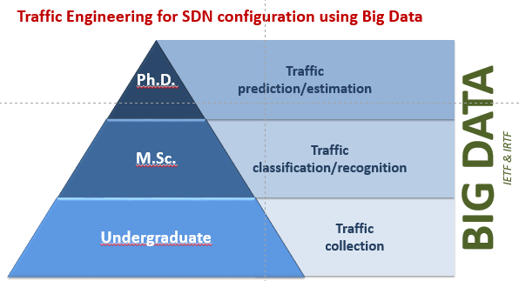
Figure 4. Computer Networks Group.

SYSTEMATIC MAPPING

To explore the status of traffic engineering in SDN, the Ing used a Systematic Mapping, it consists of: research questions, the search process, the selection process, and some initial results.

The research questions for this exploration are:
- RQ1. What are the different solutions for implementing traffic engineering in SDN?
- RQ2. What research topics about traffic engineering in SDN are being addressed?
- RQ3. What are the limitations of current investigation about traffic engineering in SDN?

The process of Research used
Keywords: “software-defined networking” and “traffic engineering“
Associated terms: Discard terms due to low search frequency → Google Trends, Discard terms aimed to other areas
The query string were:
("software-defined networking" OR openflow OR "software defined networking" OR "software defined network" OR "software defined networks“)
AND
("traffic engineering" OR "traffic management" OR "traffic analysis" OR "traffic monitoring" OR "traffic classification" OR "traffic prediction" OR "traffic steering")

The figures 5 and 6, show that from 2011 and 2015, there was an increment in the number of papers related to traffic engineering in SDM. Only ACM presented a small decrease in 2015 compared with the number in 2014.

Figure 5. Paper per source and per year

Figure 6. Number of paper per source and per year.

The Figure 7, show the total number of papers per year.

Figure 7. Total number of papers per year.
Selection criteria. The criteria used for the selection of the paper were: Inclusion criteria: Propose traffic engineering solutions for managing SDN-based networks. Exclusion criteria: Literature review papers and Papers not subject to peer reviews.


Figure 8. Candidate papers per source and per year.
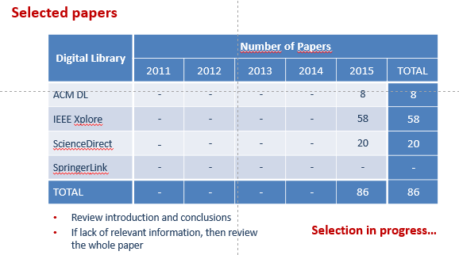
Figure 9. Selected papers.
The figure 10, shows that (1) most of the work focuses on addressing performance issues, specially load balancing and congestion avoidance, (2) an important number of papers work on fault challenges, particularly fault tolerances and anomaly detection. (3) it is very uncommon the research on accounting problems, where we find one that copes with usage capabilities; and (4) Configuration, programming and Security has not been completed addressed, representing an interesting research opportunity.

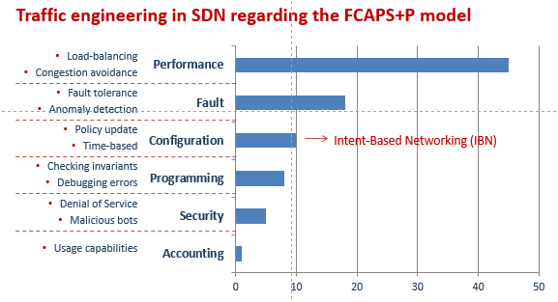
Figure 10. Papers in traffic engineering in SDN
Currents works in configuration focus on policy update and time-based configurations; in programming, papers mainly perform checking invariants and debugging errors; and in security, works concentrate on denial of service and malicious bots. It I noteworthy that addressing configuration issues may support other functional areas, such as performance and fault.

The figure 11, shows that the mechanisms for traffic engineering in SDN, most of the work focus on traffic monitoring without performing additional actions. The traffic collections, classification, steering and prediction are interesting research opportunities. It is important to mention that traffic steering is more related to Network Function Virtualization, or NFV, which can represent an attractive use case for SDN.

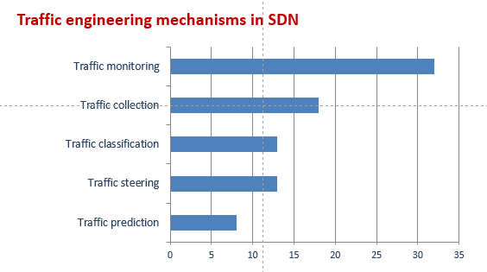
Figure 11. Traffic engineering mechanisms in SDN

Through this data extraction, It was also important to classify the papers regarding the network context, the data context, and the outcome, in order to focus the proposal. The Figure 12 shows this classification.

Figure 12. Classification scheme categories.

Conclusions are:

- Applying traffic engineering for solving SDN configuration issues represents an interesting research topic
- Traffic prediction in SDN presents an attractive research opportunity
- Complementing the systematic mapping will provide better insight about traffic engineering in SDN
  - Which network context should be addressed in this project?
  - Which are the specific techniques for conducting traffic collection, classification, and prediction in SDN?
  - How many papers use Big Data for applying traffic engineering in SDN?

Ph.D. Study Plan:
2016
- Survey paper
  - IEEE Surveys and Tutorials
  - Review about using Big Data for managing SDN
- Courses
  - Research Seminary I
  - Thesis III – Ph.D. thesis proposal
- Research internship
  - University of Waterloo, Professor Raouf Boutaba
  - Conference paper
    - Initial results of research internship
    - COMPSAC 2017
- * Journal/Conference paper
  - Systematic mapping study

2017
- Journal paper
- Conference paper
- Courses
  - Research Seminary II
  - Teaching Practice
2018
- Journal paper
- Conference paper
- Courses
  - Research Seminary III
  - Teaching Practice
  - Thesis IV – Ph.D. thesis

- Intervención del co-relator

El Ingeniero Caicedo, comenta que la charla se realizó en inglés debido a que el estudiante debe prepararse para su estancia doctoral, la cual está próxima a desarrollarse a partir del mes de Septiembre del presente año, en la Universidad de Waterloo, con el Profesor Raouf Boutaba. También se aclara que hay poco tiempo, pero pues ya se han definido las fechas, por tanto, hay que darle un poco más de velocidad a la propuesta del anteproyecto.

- Preguntas

Pregunta 1. Se requiere tener aprobado el anteproyecto para hacer la pasantía?. Respuesta: El Coordinador del Seminario aclara que se puede iniciar la pasantía con el trabajo avanzado pero no se puede acceder al apoyo económico. El Ing. Caicedo complementa que son conscientes de que hay poco tiempo pero, es imperativo que el estudiante inicie su pasantía en el tiempo establecido, la cual tendrá una duración de 9 meses.

Pregunta 2. Se pregunta sobre cómo se definieron y aplicaron los criterios de selección y exclusión de los artículos (por qué se excluyen los reviews). El Ingeniero Estrada, nuevamente explica el proceso seguido, para obtener estos criterios, teniendo en cuenta la naturaleza del tema.

Pregunta 3. Se pregunta sobre cuáles son los parámetros que se van a utilizar para el proyecto? El Ingeniero Estrada, contesta que al momento no se han definido, dado el estado de avance de la propuesta.

- Conclusiones

El coordinador agradece la presentación y da por finalizada la sesión.

Se termina la sesión.

